Faculty Profile
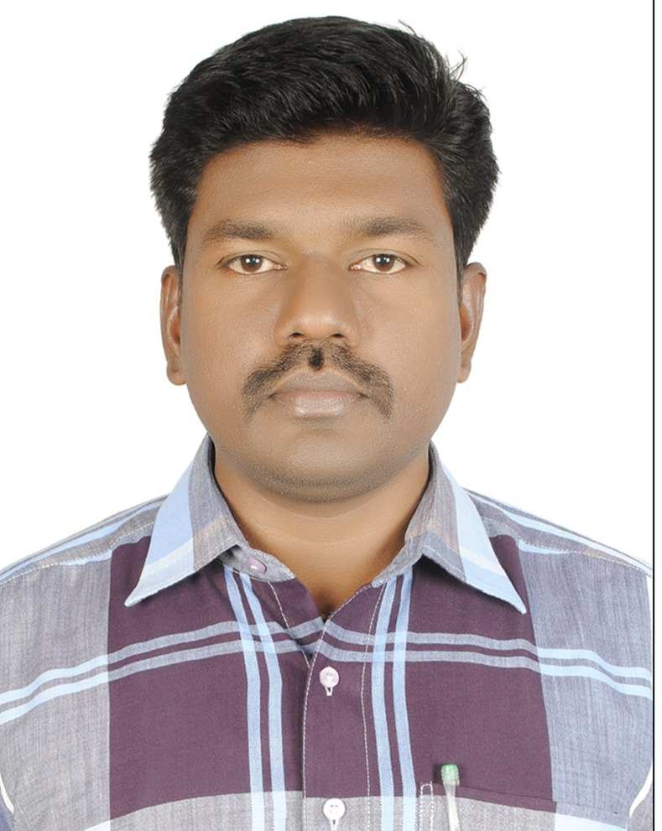

Srinivasulu Munagapati
Lecturer in Electronics,
Govt. Degree College for Men (A), Kadapa,
Andhra Pradesh.
Contact: 9908470069
Email: srinivasulumunagapati@gmail.com
----------------------------------------------------------------------------------------------------------------------
Name : M.Srinivasulu
Father Name : M. Rama subbaiah
Sex : Male
Date of Birth : 12/06/1978
Marital Status : Married
Address for
Communication : H.NO.39/49-76,
Sri Krishnadevaraya Colony, Kadapa
Andhra Pradesh - 516002
Mobil No : 9908470069
E-Mai ID : srinivasulumunagapati@gmail.com
Designation : Lecturer in Electronics
College : Govt . College for Men {A} Kadapa
Qualification : M.Sc., M.E., NET.
Academic Record:
S.No | Course | Institute/University | Year of Passing | % of Marks | Division
1 | Post Graduation | Sri Venkateswara University, Tirupati | Jan. 2002 | 76 % | First
2 | Master of Engineering | Sathyabama University, Chennai | April. 2011 | 78% | First Class with Distinction
3 | NET | UGC | 2012 | ---- | -----
Professional Experience:
S. No | Name & Address of Institute | Post held | From | To | Job Type
1 | Govt. College for Men(A), Kadapa | Lecturer in Electronics | 09.08.2018 | Till date | Contract
2 | Govt. Degree College,Porumamilla | Lecturer in Electronics | 21.06.2017 | 08.08.2018 | Contract
3 | Govt. College for Men(A), Kadapa | Lecturer in Electronics | 25.09.2003 | 31.03.2017 | Contract

M. SRINIVASULU

