FACULTY PROFILE
CHARUGUNDLA RAMU,
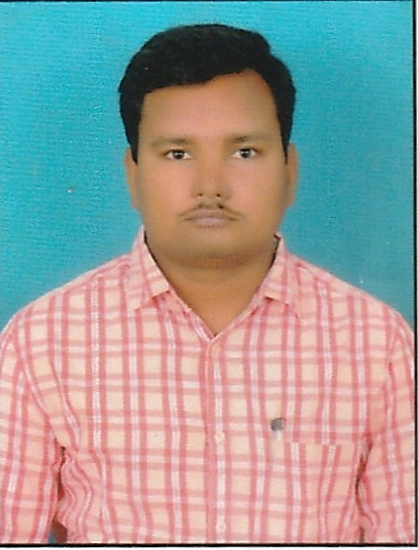
Lecturer in English,
Govt College for Men(A),
Kadapa District,
Andhra Pradesh-516004.

Email : ramucharugundla44@gmail.com
-------------------------------------------------------------------------------------------------------------
Name &Address | Sri. Ch. Ramu, Lecturer in English, Govt College for Men(A),Kadapa.
Date of Birth | 20-03-1983.
Educational Qualifications | - M A in English Completd in 2009-12 with 62.35%  - M Ed Completed in 2014 with 68%  - APSET Completed.
Area of Expertise | Shakespeare, Milton & Indian Poetry in English
Teaching Experience | - Two years as School Assistant from 01-06-2016 to 24-06-2025 at ZPHS,  - Bommavaram, Obulavaripalli Mandal, Kadapa Dt.  - Working as Degree Lecturer in English since 25-06-2018 to Till now.
Lecturer in English.
1.TRR Govt. Degree College,Kandukur(25-06-2018 to 05-10-2021)
- Library in charge,
- Examinations Coordinator,
2.MRR Govt. Degree College, Udayagiri(05-10-2021 to 04-03-2023)
- Library in charge,
- JKC Co-ordinator,
3.Govt Degree College, Puttur( 04-03-2023 to 21-07-2023)
- JKC Co-ordinator,
4.Govt College for Men(A)(22-07-2023 to Till date)
- JKC Co-ordinator.
Professional Training Programs attended | - Completed Online Refresher Course in English Language Teaching from 30-03-2019 to 29-05-2019 from Gujarath University, Ahmedabad.  - Completed Faculty Development Programme on History of English Language and Literature on Sep- Dec2020 NPTEL-AICTE  - Completed Orientation Programme from 21-08-2022 to 19-10-2022 from Ramanujan College University of Delhi.  - Participated in Training in English Teaching for Govt Degree College Faculty conducted by EFLU, Hyderabad from 30-01-2024 to 03-02-2024.  - Participated in Training in English Teaching for Govt Degree College Faculty conducted by EFLU, Hyderabad from 15-07-2024 to 20-07-2024.
State/National Seminars attended  Workshops attended | - Attended two days work shop at GDC Rapur, SPSR Nellore Dt,. And presend a paper on “ Innovative Teaching Skills Development Knowledge Transfer in 2021.  - Participated in One Day State Level Seminar on ‘’Recent Trends In Aquaculture’’ 30- Sep-2022 at MRR Govt. Degree College, Udayagiri, SPSR Nellor Dt.
Guest Lectures/Workshops Conducted: | Conducteda Guest Lecture on Presentation Skills and An Interactive Session with the Poet & Writer, Dr. KV Raghupathi on 12.10.2023 at GCM(A) Kadapa. The resource person of the programme was Dr. KV Raghupathi, Retired Professor – English, Dept. of English, Central University of English, Thiruvarur, T.N.

