RESUME

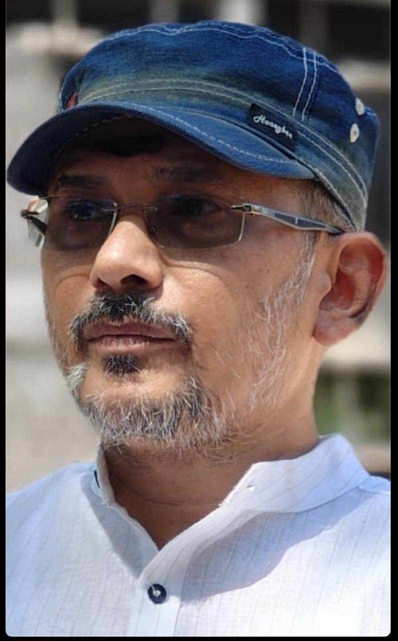
- Name of the faculty : Dr. SATISH R CHADEVE
M.A., M.Phil., Ph.D., APSET
UGC-NET.,
- Designation : Lecturer in English
- Date of Birth : 22/02/1980
- Permanent residential address:

Dr. C. Satish Reddy,
Flat Number 104, Garudadri Residency
PF Office Down, Gandhi Nagar
Kadapa-516004
Andhra Pradesh

- Community : OC
- Nationality & Religion : Indian, Hindu
- Contact Number : (+91) 9966467799
- E-mail : satishchadeve@gmail.com
- Date of first post appointment
as JL & Working place : 16/12/2004, Vayalpadu, Chittoor Dist.

- Date of Promotion as
DL & Working place : 23/05/2013, Kadiri, Anantapur Dist.

- Date of joining in the present
Working Place : 24/09/2021, GDC Men (A), Kadapa.
- Date of Retirement : 28/02/2042
- Present residential address:
Dr. C. Satish Reddy
Flat Number 104, Garudadri Residency
PF Office Down, Gandhi Nagar
Kadapa-516004
Andhra Pradesh

- Educational Qualifications:

S.No | Course Study | Group/Specialization | Certificate  No | From-To | Institution/University | Percentage
1. | Ph.D. | A study of Select American Slave Narratives of Antebellum Era. | 007208 | 9/7/2021 | Sri Venkateswara University, Tirupati
2. | M.Phil. | A study of select American Slave Narratives. | 006287 | 2014-2017 | Sri Venkateswara University, Tirupati, A.P. | 64%
3. | M.A | English Literature. | 002039 | 2000-2002 | Loyola College, Chennai, Madras University, T.N. | 63%
4. | B. A | Spl. English, History, Political Science. | 971302 | 1997-2000 | Andhra Loyola College, Sri Nagarjuna University, A.P. | 71%

- Qualifying Test for Assistant Professor/Lectureship:

S. No | Test Name | Certificate  No | Year of Passing | Percentage (%)
1. | AP SET | 210708313 | 2012 | 78 %
2. | UGC-NET | 46300313 | 2013 | 64 %

- Academic Staff College Orientation/ Refresher Course attended:

S.No | Name of the Course/ Summer School | Place | Duration | Sponsoring Agency
1. | Refresher Course in ‘Disaster Management’. | SV University, Tirupati | 08/12/20014 to 27/12/2014 | UGC
2. | 28thOrientation Programme | MANU, Hyderabad | 02/12/2015 to 29/12/2015 | UGC
3. | Refresher Course in ‘Comparative Literature’. | MANU, Hyderabad | 04/09/2018 to 24/09/2018 | UGC
4. | FDP: ‘Making Next Gen Learners’ | Online, CCE. | 31/08/2020 to  04/09/2020 | CCE
5. | Refresher Course in ‘English’. | Online SV University Tirupati | 03/03/2022 to  16/03/2022 | UGC
6. | Refresher Course in ‘Health Management’. | Hybrid Mode (Online/Offline)  SV University Tirupati | 10/08/2023 to  23/08/2023 | UGC
7. | FDP: Applications of AI | Online, Dr. V. S. Krishna Govt. Degree &PG College (A), Visakhapatnam | 23-02-2026 to 13-03-26 | CHE

- Particulars of Publications:

Single Author Books:

- C. Satish Reddy, Suicide is Suicidal; Sri Sai Ganesh Graphics, Hyderabad, 2019, ISBN 978-93-5361-981-7 https://amzn.in/d/8a3zGld

- Dr. C. Satish Reddy, Nature's Child; Bigfoot Publications, Gurugram, Haryana, Dec, 2023,
ISBN 978-8119512744

- Dr. C. Satish Reddy, Archetypal Approach to ‘The Panchatantra’; Bigfoot Publications, Gurugram, Haryana, Feb, 2024, ISBN 978-81-970098-3-9

- Dr. Satish R Chadeve, Blossoms of The Broken Branches; Bigfoot Publications, Gurugram, Haryana, Apr, 2024, ISBN 978-81-971756-2-6

- Dr. Satish R Chadeve, Love’s Little Melodies; Bigfoot Publications, Gurugram, Haryana, Feb, 2026, ISBN 978-93-6347-478-9

Research Papers:

- As First Author:

- C. Satish Reddy, Predestination in Oedipus the King by Sophocles, International journal of Humanities and social Science Studies (IJHSSS), Vol.1, Issue 3, 2014, 179-182, (ISBN Number print 2349-6711) impact factor 6.8
https://drive.google.com/file/d/1k8zBjhoKW-R4ENjPha-2EwkgdReZ6KJJ/view?usp=drive_link

- C. Satish Reddy, GM Sundaravalli, Seven Years in the dark for freedom: Harriet Jacobs, International Journal of Multidisciplinary Educational Research (IJMER), Vol.8, Issue 8(4), 2019, 77-84, (ISSN Number 2277-7881) Impact Factor 10.16
https://drive.google.com/file/d/1aY_c-bm2MeJv38LEiZAwhy5pW1p_Vw4x/view?usp=drive_link

- C. Satish Reddy, GM Sundaravalli, Born Slave and liberator by choice: Frederick Douglas, SVU Journal of English Studies, Vol.18, July 2019, 93-98, (ISSN Number 2230-7923)
https://drive.google.com/file/d/1tc3hnnRG1blODWQmJ8N9QkEc2Hg1q92W/view?usp=drive_link

- C. Satish Reddy, GM Sundaravalli, By Birth a Slave, by Struggle a Fugitive Slave & by Gift a Freeman: William Wells Brown, International Journal of Humanities & Social Science Studies (IJHSSS), Vol.6, issue.4 February 2020, 50-55, (ISSN Number 2349-6711) impact factor 6.8
https://drive.google.com/file/d/1luTQA7ezPanJu-QjoRUy9VGd6D_lVa_5/view?usp=drive_link

- C. Satish Reddy, GM Sundaravalli, Free Man, Kidnapped into Slavery and Miracle Liberation: Solomon Northup, The Criterion: An International Journal in English Vol. 11, Issue-I, February 2020, 107-119 (ISSN: 0976-8165) IMPACT FACTOR 7.61
https://drive.google.com/file/d/1vvUctwawCajYHfeUFihTl2AXrDyZV6TD/view?usp=drive_link
- C. Satish Reddy, GM Sundaravalli, Manumitted from Slavery before the American Civil War: Bethany Veney, The Criterion: An International Journal in English Vol. 11, Issue-I, February 2020, 130-138 (ISSN: 0976-8165) IMPACT FACTOR 7.61
https://drive.google.com/file/d/17bQ1IDkTwnnHclUtuUHEPy3bItprYWjT/view?usp=drive_link
- C. Satish Reddy, GM Sundaravalli, Major Themes in Select Slave Narratives of Antebellum Era of America, Contemporary Literary Review India, Vol. 7, No 1, February 2020, 60-81. (Online ISSN: 2394-6075) IMPACT FACTOR 7.261
https://drive.google.com/file/d/1SlcoxMwyG_aRYWd_4hkenMER1IGrvRCq/view?usp=drive_link

- C. Satish Reddy, GM Sundaravalli, Abuse of Black Women in Antebellum Era as Represented in Slave Narratives, Rock Pebbles Vol. XXIV, No. I & II, March & June 2020, 209-213 (ISSN: 0975-0509)
https://drive.google.com/file/d/1cBUi1PF-uga0tGALODctuEs4aMq_gI_J/view?usp=drive_link

- C. Satish Reddy, GM Sundaravalli, Transatlantic Slave Trade & Slavery in American, The Criterion: An International Journal in English Vol. 11, Issue-III, June 2020, 139-146 (ISSN: 0976-8165) IMPACT FACTOR 7.61
https://drive.google.com/file/d/1yc3ffVWQ5nZR3XGTFX4BpCVnxGdc363O/view?usp=drive_link

- C. Satish Reddy, GM Sundaravalli, Antebellum Slave Narratives & American Civil War, The Criterion: An International Journal in English Vol. 11, Issue-III, June 2020, 170-177 (ISSN: 0976-8165) IMPACT FACTOR 7.61
https://drive.google.com/file/d/1PfmwCRFyQQi4RINrN8dYCpy-5LUn7KvE/view?usp=drive_link

- C. Satish Reddy, GM Sundaravalli, Problems of Identity with the Usurp of Slaves Names, CLRI Contemporary Literary Review India Vol. 7, No.3, August 2020, 48-59 (ISSN: 2394-6075) IMPACT FACTOR 7.61
https://drive.google.com/file/d/1vGt1-iW9QFESNyL5jVcmwo96V9O7gxiX/view?usp=drive_link

- C. Satish Reddy, Slavery as a “Necessary Evil” in the Antebellum Southern United States of America: A Critical Examination of Pro-Slavery Validations and the Disturbed Human Conscience, The Criterion: An International Journal in English Vol. 16, Issue-IV, August 2025 (ISSN: 0976-8165) PAGE 943-954 IMPACT FACTOR 7.61
https://doi.org/10.5281/zenodo.17057937

- C. Satish Reddy, Suspense and Narration in O. Henry’s After Twenty Years and R.K. Narayan’s An Astrologer’s Day, The Criterion: An International Journal in English Vol. 16, Issue-V, October 2025 (ISSN: 0976-8165)Page 572-582 IMPACT FACTOR 7.61
https://drive.google.com/file/d/1A-8riiFZtYQWE8_jARSo1OoGmWjdiyWk/view?usp=drive_link

- C. Satish Reddy, The Serpent and the Sword: Erotic and Phallic Symbolism in Shakespeare’s Antony and Cleopatra, Galaxy: International Multidisciplinary Research Journal Vol. 14, Issue-VI, November 2025 ISSN:2278-9529 page No 11-21 Impact Factor 6.017
https://doi.org/10.5281/zenodo.17830110

- Particulars of Seminars/workshops/short term courses/conferences attended.

- Participated in “ELF Workshop” conducted at Gurukulam, Intermediate Staff Training Academy, Commissionerate of Collegiate Education, Nampally, Hyderabad, scheduled from 30.01.2014 to 01.02.2014

- Attended the State Level on “Human Resource Development in Higher Education and The Role of Government Degree Colleges in A.P”, organized by GCGTA, A.P., held at Senate Hall, Sri Venkateswara University, Tirupati on 13th Dec, 2014.

- Attended the Workshop on “Human Values & Professional Ethics” held in SKR & SKR Govt. College for Women, Kadapa on 24th January, 2015.

- Participated in UGC Sponsored ‘National Symposium on Modern Fiction’ held on 19th March 2015.

- Participated in the three-day workshop on “Teaching Language in CLT and Employability Skills” from 29th July – 8th August, 2015, jointly organized by Commissionerate of Collegiate Education in association with RUSA and Regional English Language Office, US Embassy, New Delhi. (As the recourse person fell ill it was reduced to three-day workshop)

- Attended a national workshop, “English Language Teaching: A Socio-Linguistic Approach to Skill Empowerment”, funded by APSCHE – RUSA, during 01-02 November 2016, organized by Vikrama Simhapuri University, Nellore, A.P.

- Presented a paper on ‘Abuse of Black Women in Antebellum Era as Represented in Slave Narratives: 63rd All India English Teacher’s Conference, conducted at English Department, SV University, Tirupati, scheduled from 07.01.2019 to 09.01.2019.

- Attended ‘One day Workshop on ELL Software with Hands on Practice’ held at Govt. college for Men (A) on 3/1/2020.

- Attended two-day workshop on ‘Capacity Building Workshop for English Lecturers’ organized by CCE, A.P. at Andhra Loyola College, Vijayawada on 12th & 13th March 2020.

- Attended five-day FDP in English “Making Next Gen Learners” Speak English as The English of the Times: Empowering Learner’s through RWLS, ELT, ELLs, podcasts, videos & English Pro: A Mobile App for Pronunciation in Bharatiya Way.” organized by CCE, A.P from 31st August, 2020 to 4TH September, 2020.

- Attended one day workshop on “LMS e-Content Generation” organized by Nodal Resource Center (NRC) Govt. College for Men (A), Kadapa on 27/10/2022.

- Attended “2 Day Workshop on Learning Management System and Innovative Pedagogies” organized by CCE, A.P. at Acharya Nagarjuna University, Guntur, Vijayawada on 28th & 29th December 2022.

- Attended as Master Trainer and delivered a talk on Open Educational Resources, Podcasts in three days “Training Programme on Internship and LMS” held Nodal Resource Center (NRC) Govt. College for Men (A), Kadapa from 5/01/23 to 7/01/2023.

- Attended 5 days residential training at EFLU, Hyderabad on “Training in English Teaching for Govt. Degree College Faculty, AP” held between 04-12-23 to 08-12-23.

- Attended and successfully completed 30 hours of online “Facilitator Training Program on AI Fluency, Digital Productivity, and Employability Skills” offered by Microsoft in collaboration with Andhra Pradesh Information Technology Academy under Microsoft Diversity Skilling Program with implementation partner InfiSpark Foundation from 18-12-2023 to 22-12-2023.

- Attended one day workshop on “Empowering English Language Teachers through Activity Based Methods (Orientation on using English Pro -1)” held at GCW(A), Guntur, on 24th April 2024.

- Attended one-week residential training at EFLU, Hyderabad on “A One Week Training Programme on English Pro for the English Faculty of Govt. Degree Colleges, AP Batch-III”, held between 29-07-2024 to 02-08-2024.

- Presented a paper on ‘A Comparative Study of Female Agency and Omission in Geetha Hariharan's 'Gajjar Halwa' and Bama's 'Ponnuthayi', in the One Day Virtual National Seminar on Shifting Boundaries of Languages and Literature, organized by the Department of English, School of Social Sciences and Languages, Vellore Institute of Technology, Vellore, Tamil Nadu held on 25th November 2025.

- Academic Achievements:

- Received Annual Day FIRST PRIZE for being topper in all three years of graduation at Andhra Loyola College, Vijayawada.

- Secured FIRST RANK in the State Level Recruitment exam held by APPSC to recruit Junior Lecturers in the subject English in 2004.

- Secured 2nd place in quiz competition conducted by Sri Satya Sai Seva Samithi, Vijayawada for degree college students on 23-8-1998

- Secured 2nd place in quiz competition conducted by Sri Satya Sai Seva Samithi, Vijayawada for degree college students on 22-8-1999

- Secured 2nd place in quiz competition held for college staff celebrating Azadika Amrith Mahotchv Aug - 2022.

- Service Particulars & Experience:

- Worked as Junior Lecturer in English for 8 ½ Years i.e. 16/12/2004 to 22/05/2013.

- Working as Lecturer in English from 23/05/2013 to till date…

- Activities (Games, Sports etc):

- Games & Sports: Chess, Ball-Badminton

- NSS: Worked as NSS Programme Officer at Government Junior College, Vayalpadu, Chittoor.

- Particulars of additional responsibility other than class/research (in institution/college/university).

- Convener of Literary Committee – GDC, Mydukur.
- Convener of JKC - GDC, Mydukur.
- Convener of Career Guidance Cell - GDC, Mydukur.
- Convener of College Calendar/Magazine/News Letter – GCM (A) Kadapa. (April 2025).
- As member of other committees: GCM (A) Kadapa.
a). Coaching for Competitive Exams Committee.
b). Resource Mobilization Committee.
c). Poor Students Fund Committee.
6) Convener of College Poor Students Aid Fund Committee. (from Sep - 2025)

23. Life time memberships.

- The Association for English Studies of India (AESI).

24. Achievements as Staff Club President in 2022 while working at Govt. College for Men (A), Kadapa.

- Personally approached Honourable M.P., Y.S. Avinash Reddy and requested for sports and Gym material. Y.S. Avinash Reddy Garu has donated 5,50,000 lakhs worth material Immediately.

25. Technical Skill:

- M.S Office, Internet Browsing, Basic Usage of AI Tools,

26. Strengths:

- Energetic and self-motivated. Ability to work in team environments effectively.
- Good Communication & Interpersonal Skills.
- Sincere, honest and hardworking.
- Positive thinking & quick learner.
- Possesses the talent of frankly communicating with colleagues and team members without showing any disrespect.

27. Areas of Interest:

- Creative Writing like, Poems, Drama and also works applying literary criticism.
- Love for Nature and Learning from Nature.

